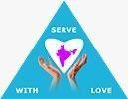
Principal
Prof. Dr. Sr. Marry Kutty.P.J Vice Principal
Sr. N. Anthonamma

Coordinators Dr.Jyothi Victoria Mrs. Khaiser Banu

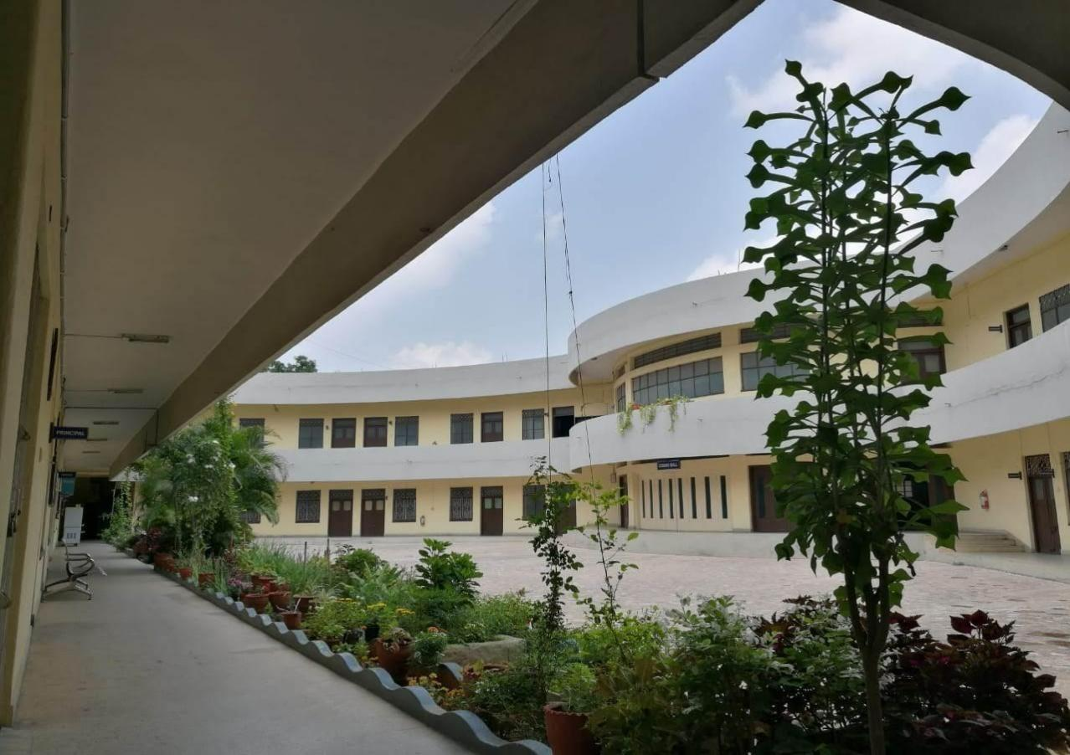

DAY I - Monday 20th November, 2023
DAY | Timings | Activity | Assignments
 | 9.15-9.30 | Assembly | Q1: Write 1-2 pages on a person you know who has influenced you a lot.
 | 9.30-10.30 | Introduction of students
Morning  Session | 10.30-11.00 | Introduction of Faculty
 | 11.00 -11.15 | Short Break
 | 11.15-11.45  11.45-12.45 | Introduction About College-Interaction with students
 |  | - Prof. Dr. Sr. Marry Kutty P.J
 |  | NCFSE 2023: Part A – Approach
 |  | Aims & curricular Areas of School Education
 |  | School Stages- Local and Design
 |  | Approach to Learning standards, Content, Pedagogy and
 |  | Assessment
 |  | Time Allocation – Dr. Lilly Chacko
 | 12.45 - 1.30 | Lunch Break
Afternoon Session | III  1.30-2.15 | Orienting students about Communal Harmony Week - Mrs. Khaiser Banu  Ice Breaking Session- GroupWise Allotment of topics Dr. Jyothi Victoria and  Mrs. Khaiser Banu
 |  | 1.We don't make services to make more money, we make - money to make better
 |  | services. Give your opinion.
 |  | - Artificial intelligence is taking over the human workforce. Justify.
 |  | 3.Teamwork -from forming to performing. Your thoughts?
 |  | - Unlearning in Education: What Do We Need to Unlearn to Improve Teaching
 |  | and Learning?
 |  | - Mental Health in Education: Strategies for Addressing Student and Teacher
 |  | Well-Being.
 | IV  2.15- 3.45 | Familiarization with the College infrastructure:/Departments Class rooms- Dr G .Madhavi  AV Room, Computer Lab Dr.Dinjanglu.P.G  Psychology Lab –Dr. Sarah Thomas
 |  | Mathematics Lab – Mrs. S.Vagdevi
 |  | Bio Lab & Prayer Room –Dr Jyothi Victoria
 |  | Physics Lab- Dr. Lilly Chacko
 |  | Social Lab-Dr. Mehaboobjan Annigeri
 |  | Gym, Sports room & Play Ground - Dr. P.Neeraja
 |  | Language Lab- Dr.Diana and Mrs. Khaiser Banu
 |  | Virtual Classroom – Dr. Ruma Roy
 |  | Library-Mrs. N. Hanna Rachel
 |  | Anand Bhavan –Dr Tarannum Irshad
 |  | Gazebo and Athenaeum-Dr T. Diana Jacob
 |  | Nari Shakthi - Mrs. S.Vagdevi

DAY- II Tuesday 21st November 2023
Morning Session | 9.15-9.30 | Assembly  Q2:list how many people have complete Trust on you. How do you know it?
 | 9:30 - 10:00 | Assembly Orientation :(Spiritual and Patriotic songs practice)  Sr. N. Anthonamma and Dr. Jyothi Victoria
 | 10:00 - 10.45  10:45 -11:00 | NCFSE2023: Part B  Cross- Cutting Themes  Rootedness in India & Indian Knowledge System Value & Disposition  Learning about & caring for Environment-Briefing about Debate - Dr. Mehboobjaan Annigeri
 | 11.00 -11.15 | Short Break
 | 11.15 -12.45 | NCFSE2023: Part B  Inclusion in Schools  Guidance and counseling in schools  Educational Technology in Schools- Dr. Ghali Madhavi
Afternoon Session | 12.45 -1.30 | Lunch
 | 1.30 - 2:15 | Subject wise syllabus Orientation by Concerned Faculty
 | 2:15 - 3:00 | Activity: Best Out of Waste – Dr. Sarah Thomas & Dr Jyothi Victoria
 | 3.00 - 3.45 | Plantation: Each one Plant one - Dr. Jyothi Victoria

DAY- III Wednesday 22nd November 2023
Morning Session | 9.15-9:30 | Assembly  Q3: What is the meaning of prosperity? Give the areas of living (e.g., food, mobile phone, house) where you feel prosperous and areas where you feel not. Explain with examples.
 | 9:30-10:00 | Orientation about Scheme of Instruction - Dr.K.Veena Latha
 | 10.00-11:00 | Spiritual talk – Dr. Fr. Sunder Dodda; Former Principal, St. Joseph’s Degree & P.G College, King Koti, Hyderabad.  Introduction -Dr.T.Diana Jacob
 | 11:00-11.15 | Short break
 | 11:15-12:15 | NCFSE 2023: Part C- School Subjects:  - Learning in the Foundational Stage  - Language Education  - Social Science Education  - Education in Interdisciplinary Areas  - Physical Education and Well-being Dr. P. Neeraja  - Mathematics Education  - Science Education  - Art Education  - Vocational Education  - Subjects in Grades 11 and 12- Mrs.S.Vagdevi
 | 12.15-12.45 | Different clubs / Certificate Courses - Dr.T.Diana Jacob
Lunch
Afternoon Session | 1.30-2.15 | Orientation on Teacher Competencies - Dr Sarah Thomas
 | 2:15-3:30 | Physical Activity: Sports Dr.P.Neeraja and Mrs. Khaiser Banu

DAY-IV- Thursday 23rd November 2023
Morning Session | 9.15 - 9.30 | Assembly | Q4: How many people have you helped?
 | 9.30 -10:00 | Placement Drive  Dr. Jyothi Victoria- Placement Coordinator
 | 10.00-11:00 | Mrs. Larissa  Faculty of Loyola Degree college Introduction - Dr. Jyothi Victoria
 | 11.00 - 11.15 | Short Break
 | 11.15 -12.45 | Group wise Presentation of Ice Breaking topics All mentors
 | 12:45 - 1:30 | Lunch
Afternoon Session | 1.30 - 2:00 | Mentoring - Mentor-mentee groups - Introduction within group -  Dr. Jyothi Victoria and Mrs.Khaiser Banu
 | 2:00 - 2:30 | Activity: Drawing and Painting- Dr.Ch.Nirmala
 | 2:30 - 3:45 | Poster / Collage Making -Dr.Ch.Nirmala

DAY V - Friday 24thNovember 2023
Morning Session | 9.15 - 9:30 | Assembly  Q:5 Narrate five interactions you had with others and check whether you had evaluated them based on 5 wrong properties i.e. rupa, bala, pada, dhana & beliefs. based on  rupa (body): e.g. race, color, size, gender • bala (body): e.g. physical strength  pada : e.g. position  dhan : e.g. wealth, money  beliefs: e.g. based on caste, religion, ideology, and any other beliefs
 | 9:30 - 10:15 | Physical Activity: Dr. P. Neeraja and Mrs. Khaiser Banu
 | 10.15 - 11:00 | NCFSE2023 Part D: School culture & Process -  Sr. N. Anthonamma
 | 11.00 - 11.15 | Short Break
 | 11.15 - 12.00 | NCFSE 2023 Part E: Creating a Supportive Ecosystem Capacity Building for Implementation  Ensuring an appropriate Environment for Learning Enabling & empowering Teachers  Community & family Engagement - Dr. Dinjanglu.P.G.
 | 12.00 - 12.45 | Talk by Alumni- Mrs.Minu Abraham, Alumni  Teacher, St. Ann’s school (CISCE), Secunderabad. Introduction: Mrs. Khaiser Banu
 | 12.45 - 1:30 | Lunch
Afternoon Session | 1:30 -2:00 | Literary Activities Theme:Performing Text, Dramatization - Dr T.Diana Jacob
 | 2:00 - 3:00 | Literary Activity: Conduction of Debate “Should  children be allowed to use social media” Dr. Mehaboobjan Annigeri
 | 3:00 - 3:45 | Visits to Local Area: School Visit

